ASSIGNMENT NO .4

1. Customers Table
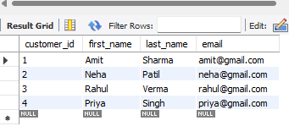

2. Orders Table

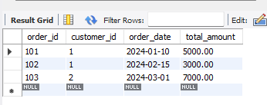

3.Products Table
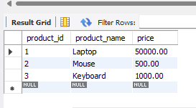

4. Order_Details Table
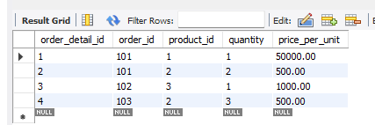

A. INNER JOIN Questions
1. Write an SQL query to display customer details along with their order details.
SELECT C.*, O.*
FROM Customers C
INNER JOIN Orders O
ON C.customer_id = O.customer_id;

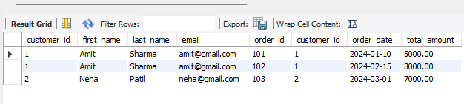
2. Retrieve the first name, last name, order ID, and total amount of customers who have placed orders.
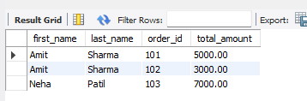
SELECT C.first_name, C.last_name, O.order_id, O.total_amount
FROM Customers C
INNER JOIN Orders O
ON C.customer_id = O.customer_id;

B. LEFT JOIN Questions
6. Write an SQL query to display all customers, including those who have not placed any orders.
SELECT C.*, O.order_id
FROM Customers C
LEFT JOIN Orders O
ON C.customer_id = O.customer_id;

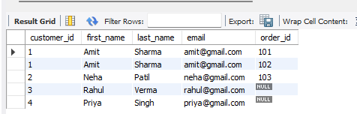

7. Retrieve customer names along with their order IDs. Display NULL for customers without orders.
SELECT C.first_name, O.order_id
FROM Customers C
LEFT JOIN Orders O
ON C.customer_id = O.customer_id;

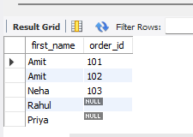

C. RIGHT JOIN Questions
11. Write an SQL query to display all orders, including those that do not have matching customers.
SELECT O.*, C.first_name
FROM Customers C
RIGHT JOIN Orders O
ON C.customer_id = O.customer_id;
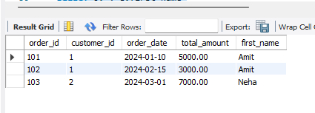

12. Retrieve all orders with customer details, showing NULL where customer information is missing.
SELECT O.order_id, C.first_name, C.last_name
FROM Customers C
RIGHT JOIN Orders O
ON C.customer_id = O.customer_id;
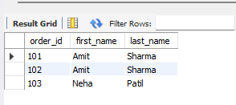

D. FULL OUTER JOIN Questions
16. Write an SQL query to display a complete list of customers and orders, including unmatched records.
SELECT C.*, O.*
FROM Customers C
LEFT JOIN Orders O
ON C.customer_id = O.customer_id
UNION
SELECT C.*, O.*
FROM Customers C
RIGHT JOIN Orders O
ON C.customer_id = O.customer_id;
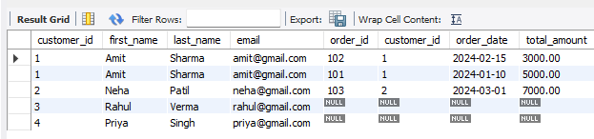

17. Retrieve customers and orders where either the customer or the order is missing.

SELECT C.customer_id, C.first_name, O.order_id
FROM Customers C
LEFT JOIN Orders O
ON C.customer_id = O.customer_id
WHERE O.order_id IS NULL
UNION
SELECT C.customer_id, C.first_name, O.order_id
FROM Customers C
RIGHT JOIN Orders O
ON C.customer_id = O.customer_id
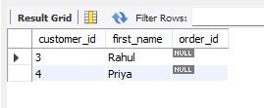
WHERE C.customer_id IS NULL;

E. Multi-Table JOIN Questions (Advanced)
21. Write an SQL query using three tables to display: • Customer name • Order ID • Product • Quantity
SELECT C.first_name, O.order_id, P.product_name, OD.quantity
FROM Customers C
JOIN Orders O ON C.customer_id = O.customer_id
JOIN Order_Details OD ON O.order_id = OD.order_id
JOIN Products P ON OD.product_id = P.product_id;

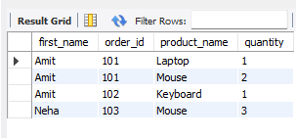

22. Retrieve all products purchased by each customer.
SELECT C.first_name, P.product_name
FROM Customers C
JOIN Orders O ON C.customer_id = O.customer_id
JOIN Order_Details OD ON O.order_id = OD.order_id
JOIN Products P ON OD.product_id = P.product_id;
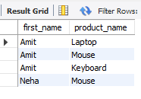

F. Output-Based / Practical Questions
26. Write an SQL query to display: • Customer Name • Order ID • Product • Total Amount

SELECT C.first_name, O.order_id, P.product_name, O.total_amount
FROM Customers C
JOIN Orders O ON C.customer_id = O.customer_id
JOIN Order_Details OD ON O.order_id = OD.order_id
JOIN Products P ON OD.product_id = P.product_id;

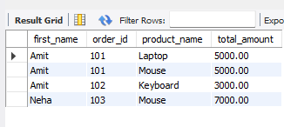

27. Retrieve customers who have placed more than one order.
SELECT C.first_name, COUNT(O.order_id) AS total_orders
FROM Customers C
JOIN Orders O ON C.customer_id = O.customer_id
GROUP BY C.customer_id
HAVING COUNT(O.order_id) > 1;

